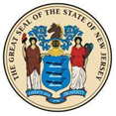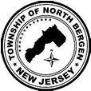

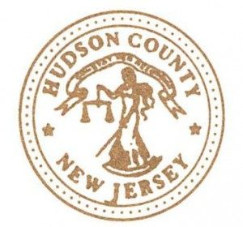

***Please Join Mayor Nicholas Sacco***

***and the Offices of***

***U.S. Senator Bob Menendez,***

***The New Jersey Secretary of State,***

***and the County of Hudson***

***For Immigration Services Day***

**Venue:**  Lawler Towers

**Date/Time:**Wednesday, February 26, 2020 from 3 pm - 6 pm

**Location:**6121 Grand Ave - Community Room

                   North Bergen, New Jersey 07047

**Topics:** Immigration/Census 2020

This forum is to inform constituents of the federal, state, county, and municipal resources that are available regardless of immigration status. In addition, this forum will highlight the importance of Census 2020 in order for constituents to understand the importance of being counted. Other topics to be discussed include:

* Services provided by the office of Senator Menendez
* Services provided by the State of NJ to residents regardless of immigration status
* Real ID, the more secure and federally compliant driver's license available in New Jersey.
* Information regarding Census 2020 presented by the County of Hudson

For more information, please contact Kerlyn Espinal, the Director of Immigration Services at the office of Senator Menendez at (973) 645-3030.